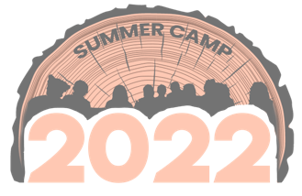
Children and Youth need camp more than ever and we are gearing up for our best summer at Glen Lake Camp and Retreat Center. Our campers will enjoy a Christian environment where authentic relationships are formed through adventures, community, and life in Christ. Glen Lake Camp has modified their summer plans for Summer 2022, while keeping safety of campers, volunteers, and staff as the number one priority.
Registration for Glen Lake Camp is a simple three step process.
1. Register for your week of camp.
register at https://www.glenlake.org/summer
YOUR LOGO
2. Pay your deposit and make payments.
3. Go to camp!
This summer, (CHURCH NAME) will be attending (CAMP WEEK & DATE).
.
Our church has committed to paying ($____) of each child’s camp costs this year.
Once you have registered for camp, please let me know.
Registration is open now and in order to save your camper’s spot, register now.
(As a camp volunteer, I am excited to spend this week of camp with our campers). If you have any questions please let me know.
Grace & Peace,
(Your Name & Contact Information)
Glen Lake Camp & Retreat Center
Patrick Turkett, Program Director
patrick@glenlake.org

